**NAME: AQSA TAUHEED (2303-KHI-DEG-011)**

**PAIRING WITH : MAVIA ALAM KHAN (2303.KHI.DEG.017)**

**&**

**MOHAMMAD HUSSAM(2033.KHI.DEG.020)**

_____________________________________________________________________________________

**ASSIGNMENT 3.4 (a + b)**

Write a component that will log metadata of your  
Classification model that you trained on the day dedicated to  
Supervised Learning. Remember to include all metadata that  
are important to track for this problem.

Run your Classification model that you trained on the  
day dedicated to Supervised Learning in MLFlow.

**SOLUTION:**

**STEP:1:**

First we downloaded the winequalityN.csv data set from kaggle and then mlproject file is a configuration file used by MLFlow to define how to run a project.so we did configiration in it.

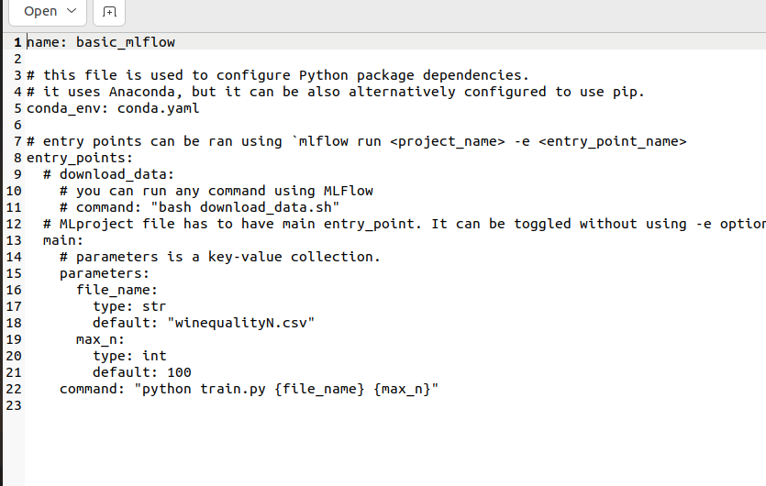

After that the conda package manager to specify the dependencies and configuration of a software environment.

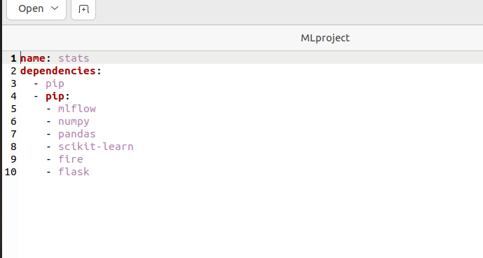

mlflow_env_vars.sh is a shell script that can be used to set environment variables that are used by MLFlow.

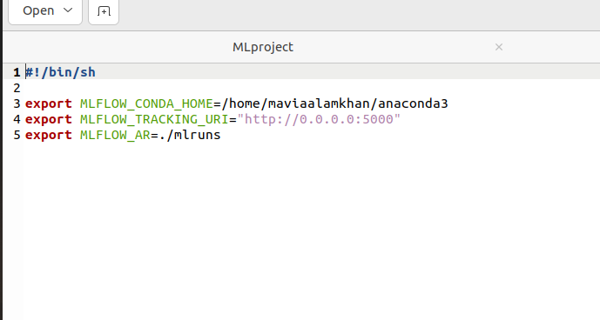

**STEP:2:**

We setup the train.py file. To log this metadata, we can create a Python module that defines a function to train the classification model and log the metadata using MLFlow

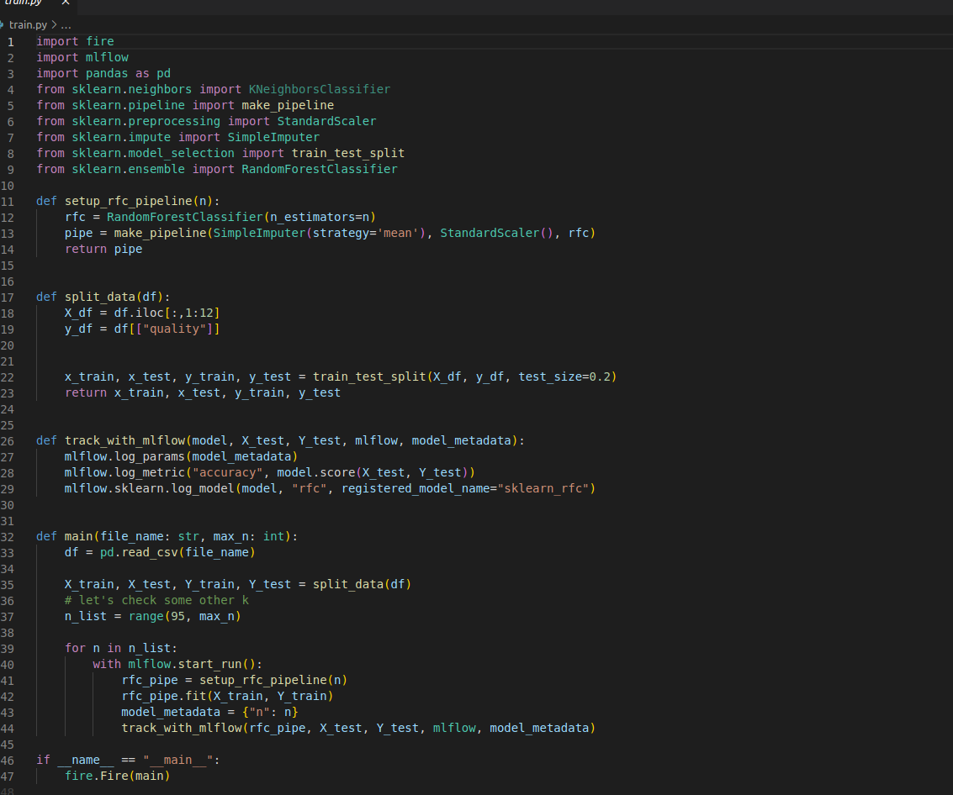

**STEP 3 :**

We used the MlFlow_lab.ipnyb file in conjunction with MLFlow to develop, test, and experiment with different models and hyperparameters.

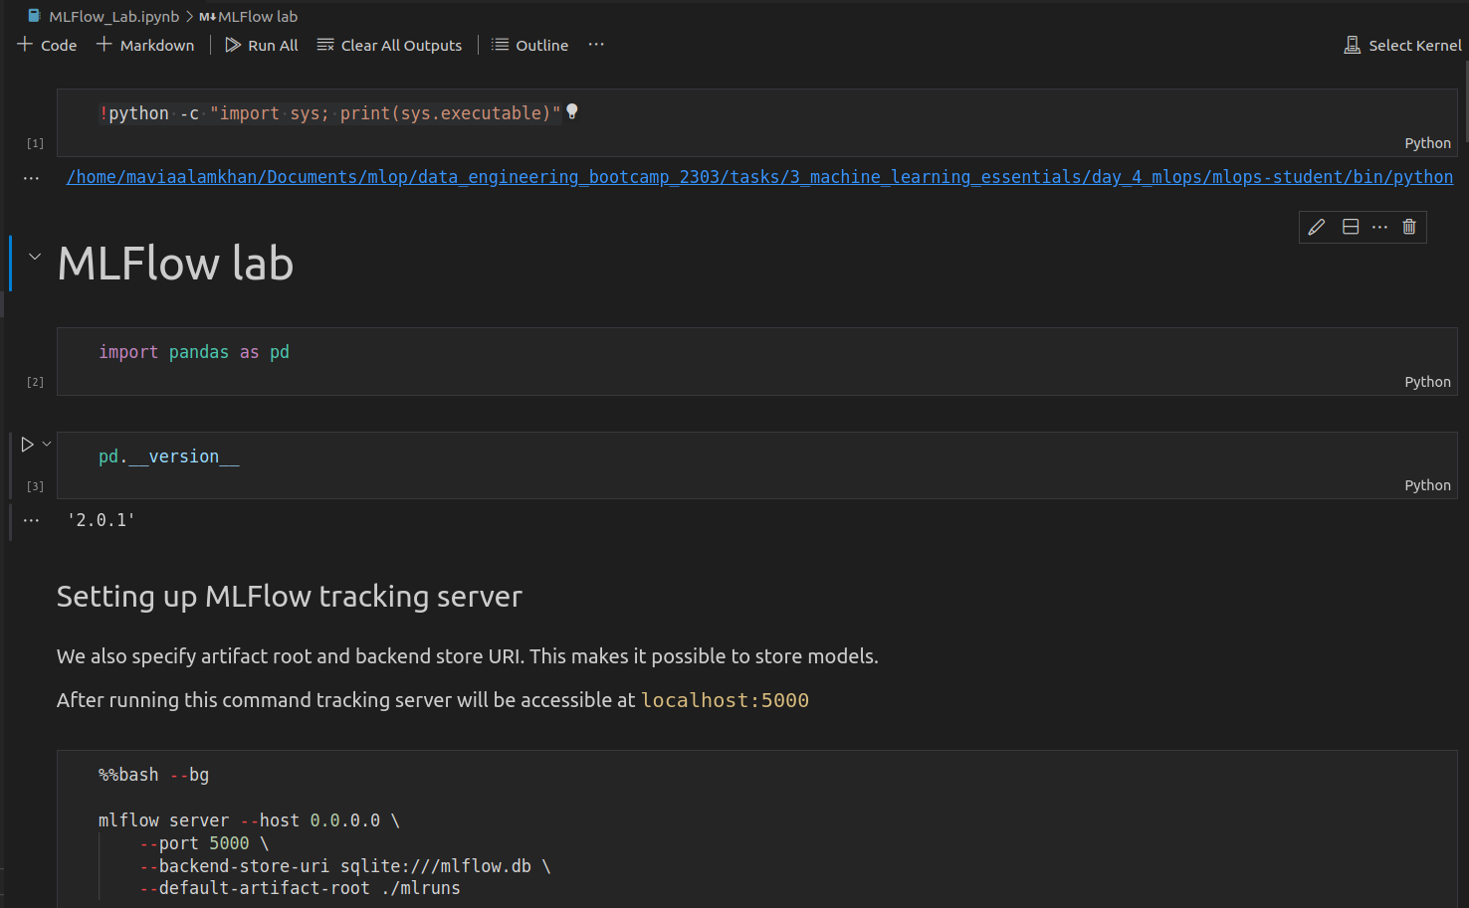

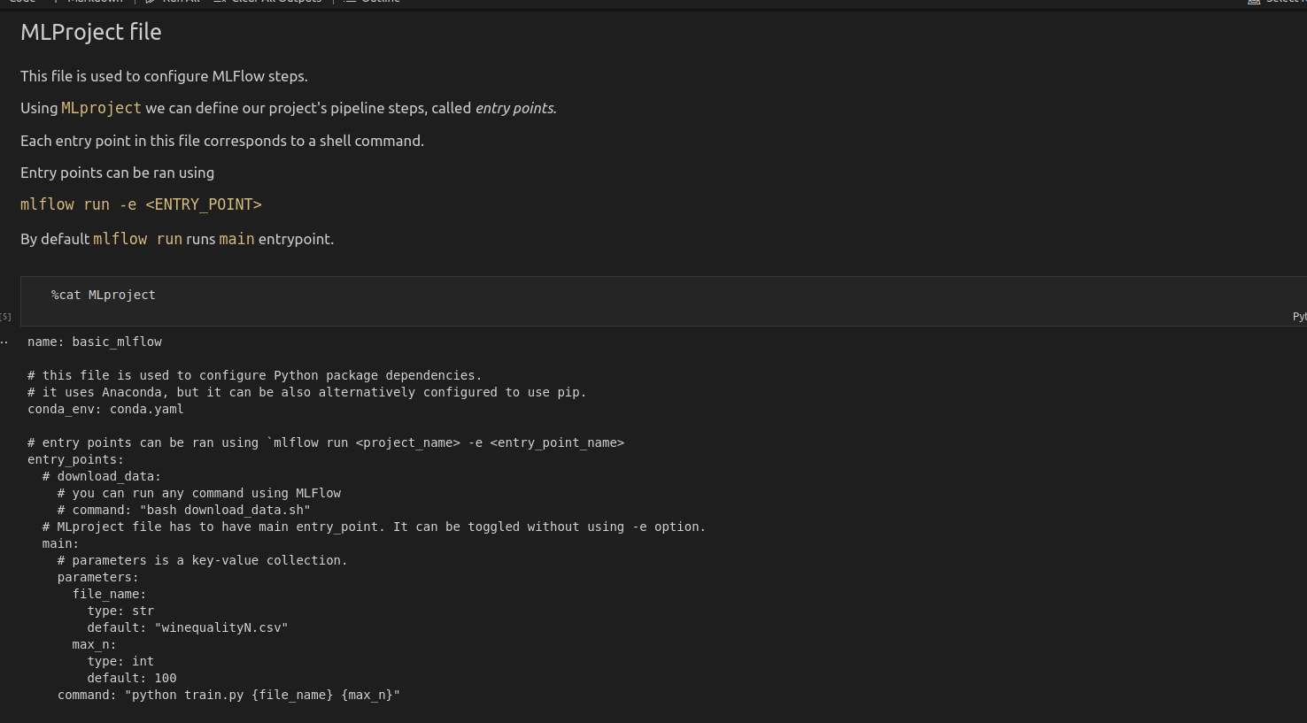

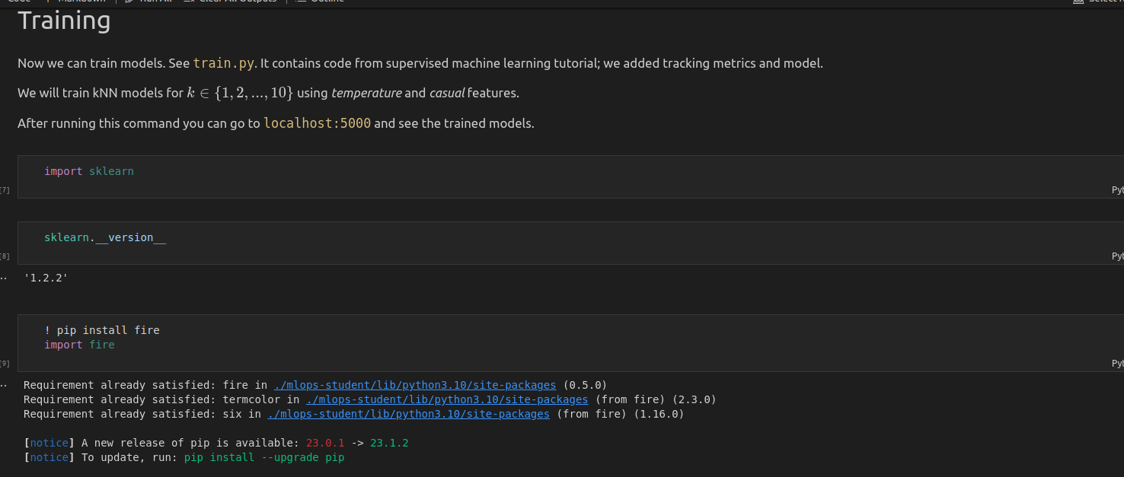by running these commands, we are able to use MLFlow to manage our machine learning experiments, including tracking the performance of our models and organizing the results of multiple runs.

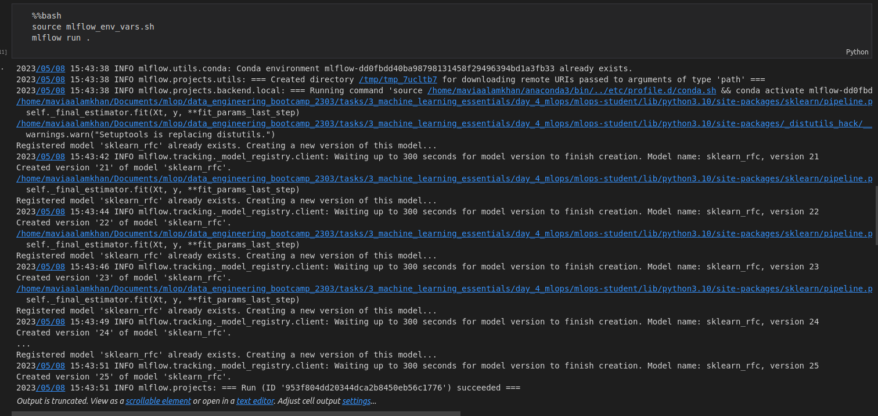

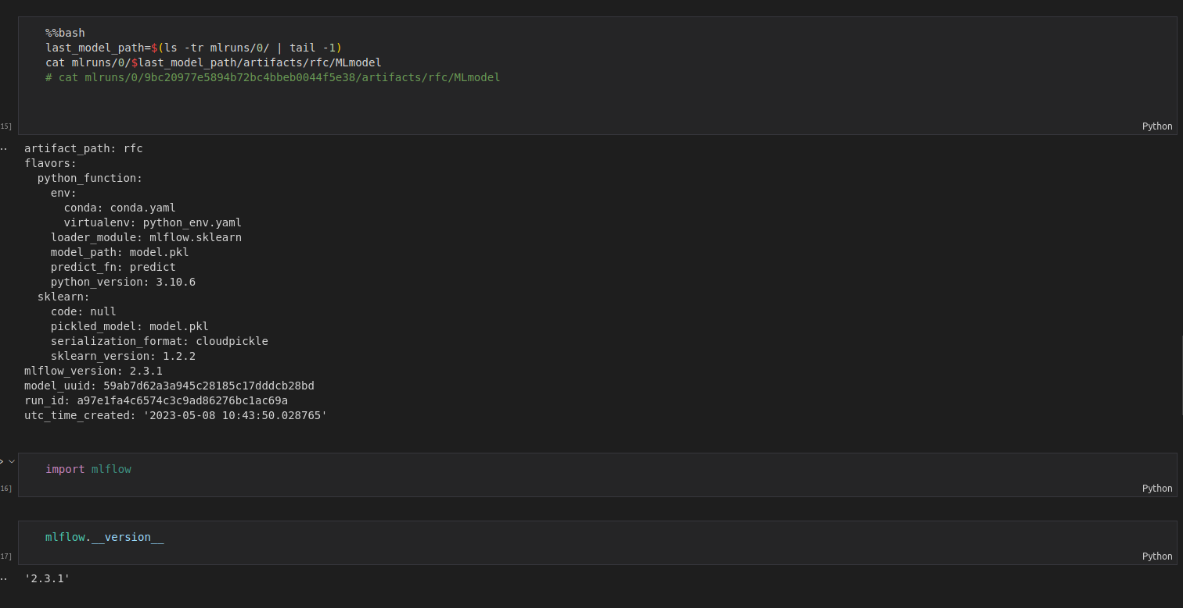

**LOGS:**

